Guitar - G major

* 滅火器

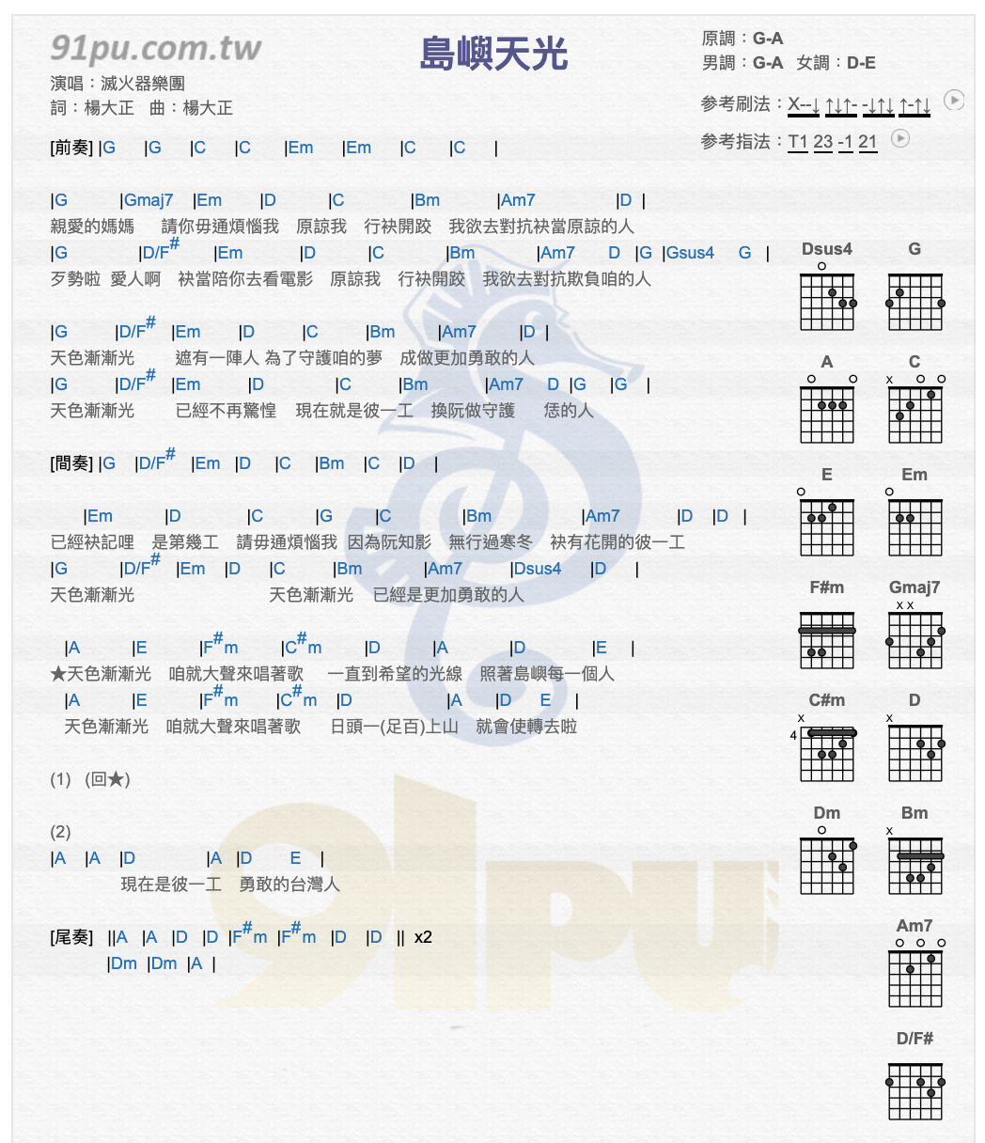

* Jay Chou

